Subjective Question

1. Which are the top three variables in your model which contribute most towards the probability of a lead getting converted?

Based on the coefficient values from below screenshot, the following are the top three variables that contribute most towards the probability of a lead getting converted:

a) Total Time Spent on Website

b) Lead Add Form (from Lead Origin)

c) Had a Phone Conversation (from Last Notable Activity)

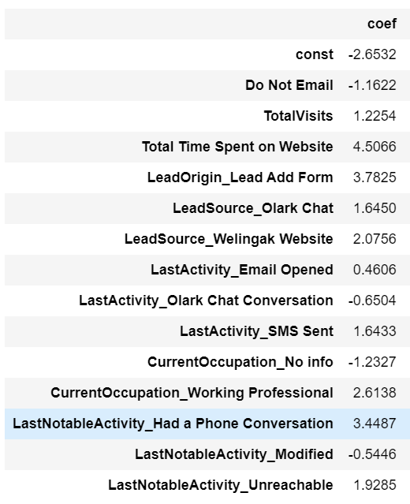

1. What are the top 3 categorical/dummy variables in the model which should be focused the most on in order to increase the probability of lead conversion?

Again, based on the coefficient values from the screenshot in the question above, the following are the top three categorical/dummy variables that should be focused the most in order to increase the probability of lead conversion:

a) Lead Add Form (from Lead Origin)

b) Had a Phone Conversation (from Last Notable Activity)

c) Working Professional (from What is your current occupation)

1. X Education has a period of 2 months every year during which they hire some interns. The sales team, in particular, has around 10 interns allotted to them. So, during this phase, they wish to make the lead conversion more aggressive. So, they want almost all of the potential leads (i.e. the customers who have been predicted as 1 by the model) to be converted and hence, want to make phone calls to as much of such people as possible. Suggest a good strategy they should employ at this stage.

Phone calls must be done if the target clients if:

1. Spend a lot of time on the website. This can be increased by making the website more interactive.
2. The clients are visiting the website more than once.
3. The last activity is through SMS or through Olark chat.
4. They are working as professionals.
5. Similarly, at times, the company reaches its target for a quarter before the deadline. During this time, the company wants the sales team to focus on some new work as well. So, during this time, the company’s aim is to not make phone calls unless it’s extremely necessary, i.e. they want to minimize the rate of useless phone calls. Suggest a strategy they should employ at this stage.

In these conditions the company must make the chat and SMS communication stronger so that clients get convinced over texts itself. This strategy will work well on lead score customers.